Assignment
1.Find any other websites or mobile applications that demonstrate excellent UX design
a) Clarity
Answer:
Google.com
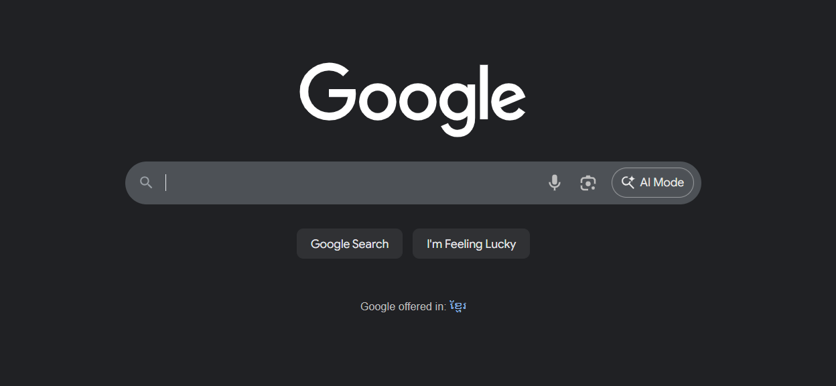
Very minimalist design. With its primary goal is to find information, all it needs is a single search bar.

b) Simplicity
Answer:
Youtube.com
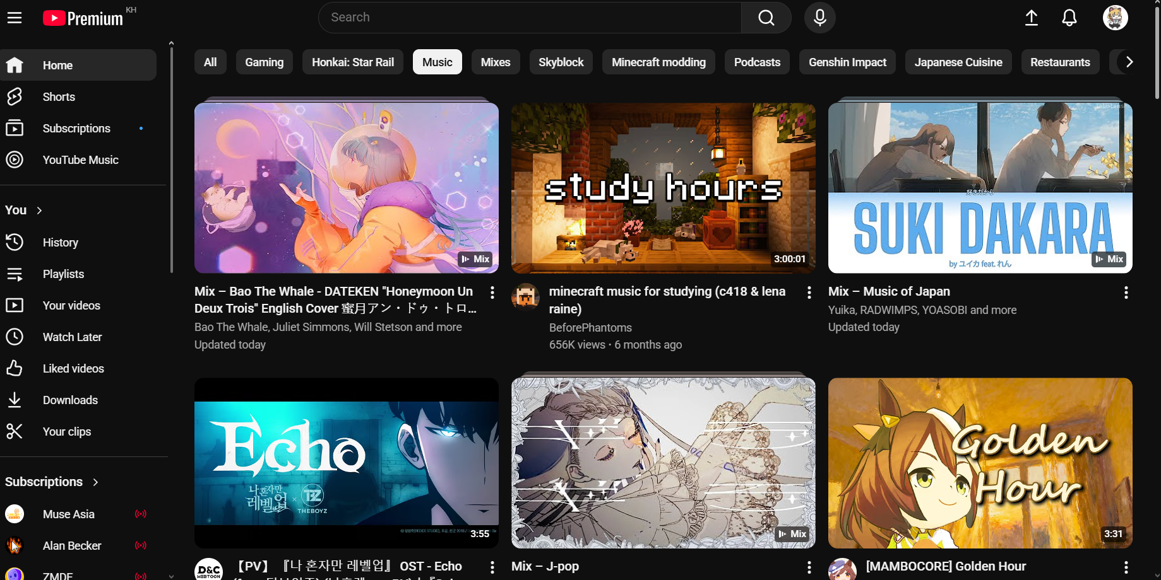
Clear and simple and design combined with adequate information and clarity on what each button and video will do/show, creates a user-friendly environment. Entertaining from single clicks makes it a must go and attracts users and returning.
c) Usability
Answer:
www.imgtools.co
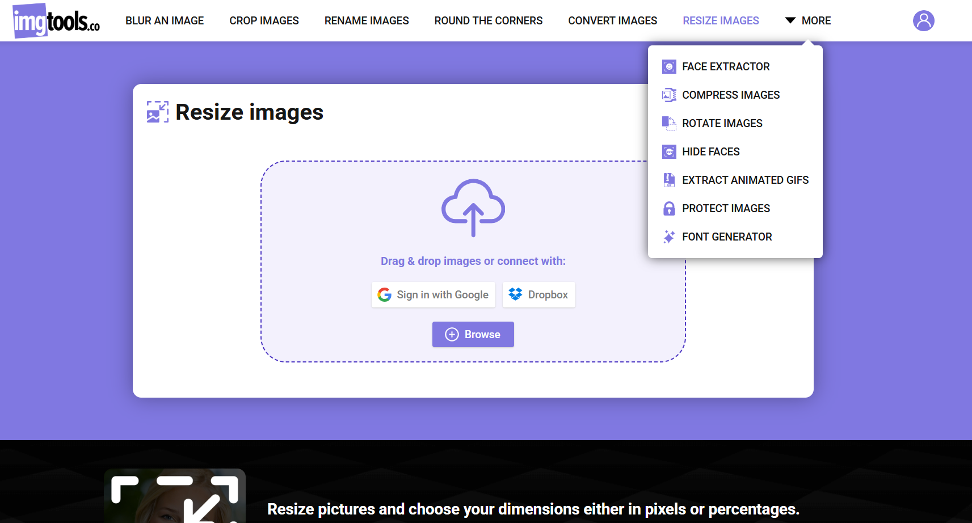
Free and simple website with various number of features included. Its able batch select and edit as many photos as u want free of charge and with many tools to satisfy basic photo editing needs.
2. Choose a website or mobile app:
answer:
moodle.ccun.edu.kh

a) How does the UX feel when you use it?
answer:
It is confusing to use and extremely confusing for new users. The design although its minimalistic. It lacks color and design and is not visually appealing. it’s just blue letters and blank white background. 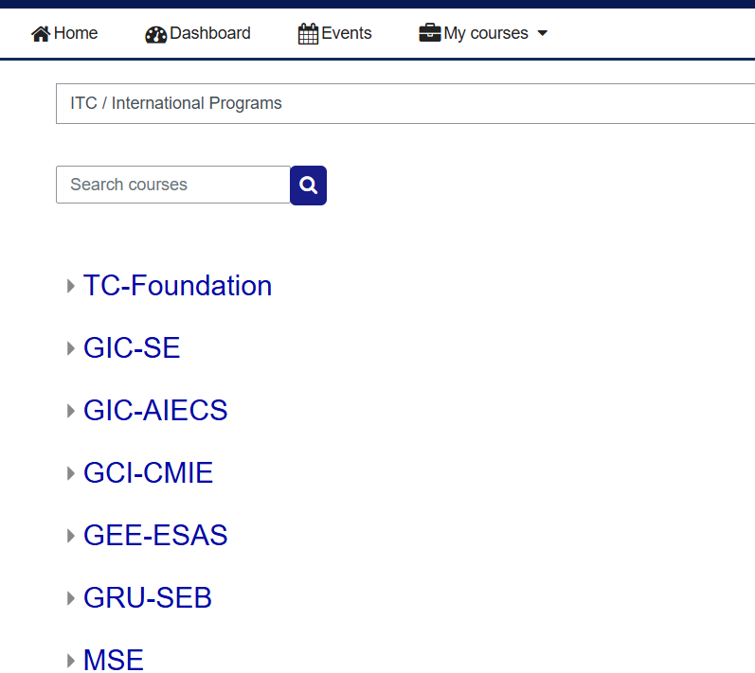
While these 2 features are quite useful it shows what happens during each day of the month. Also some colors, textures and title for each subject is a nice touch.
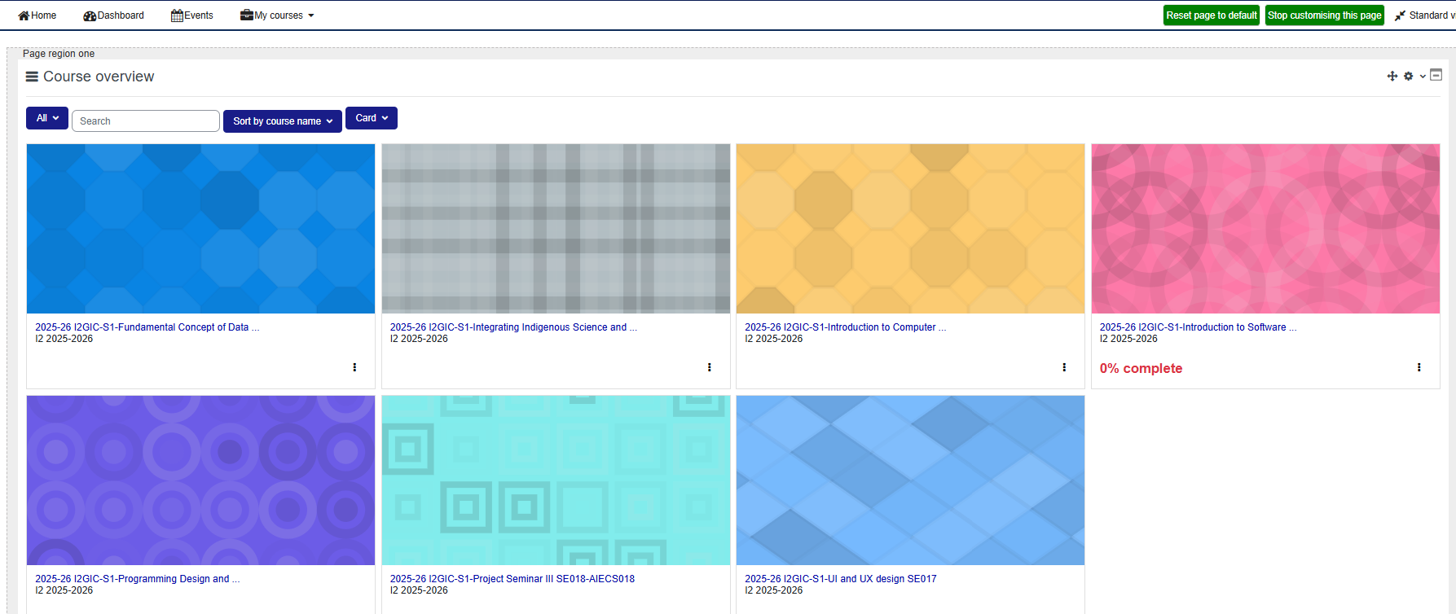
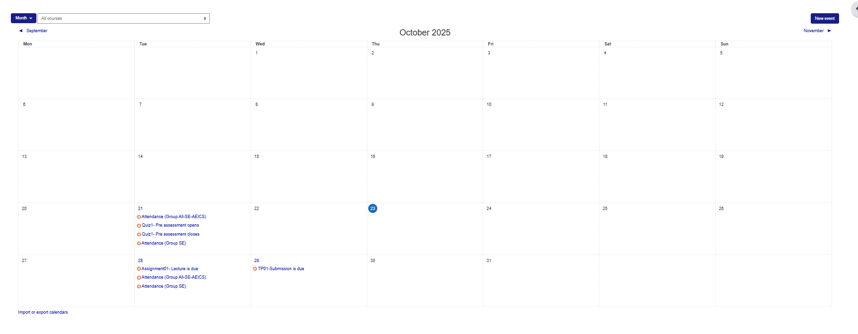

c) Which type of information architect does this product use?
answer:
It is heavily built on category based. Everything is. Can see in the picture in part a).
There is category for pretty much everything but It does make it easy to navigate
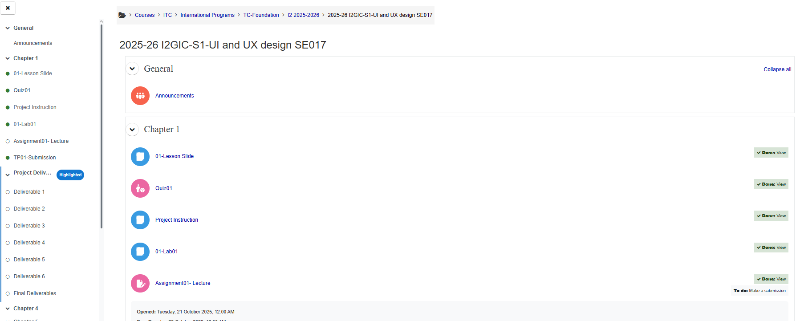
d) Draw sitemap of this product.
answer:
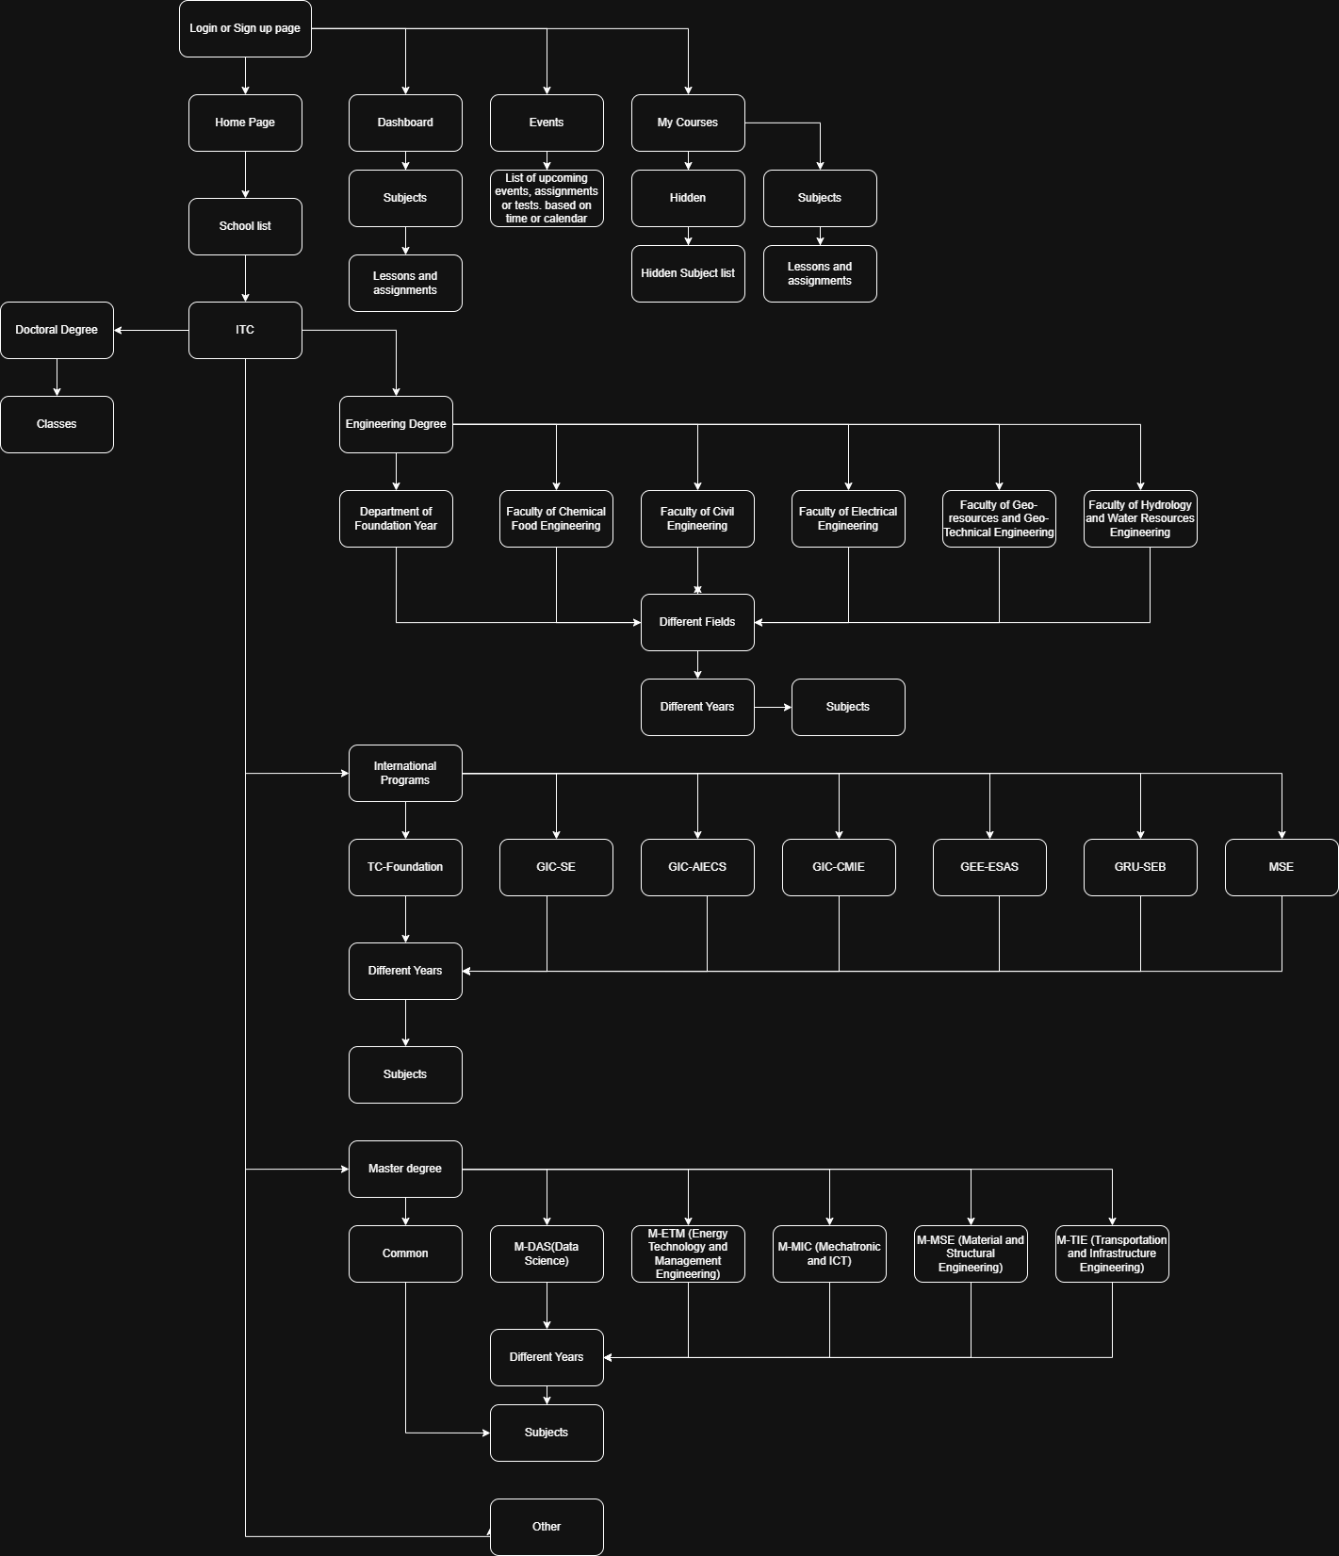

e) Which design pattern does this product use?
answer:
F Pattern.
3.
App: e-gets
Goal: Order food, drinks or items.
Steps: Open app > Select restaurant or shop > select food or item > add to cart > select delivery location > select payment options > confirm order
Problem: Too many clutters, every time u go back to home screen there’s ads, constant ads on discounts.
Improvement: Combine the place and confirm order within the menu of each restaurant or shop.

